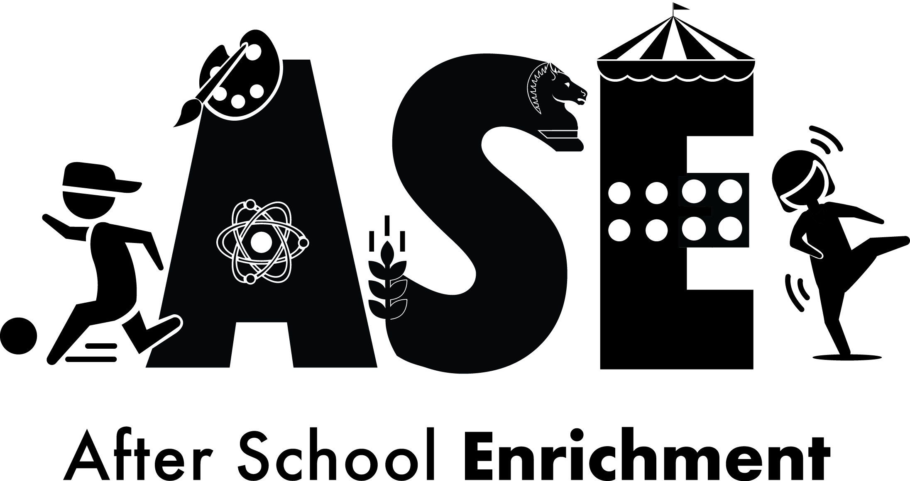 Spring 2019

The McKinley School Foundation is pleased to offer After School Enrichment (ASE) Program classes this Spring from January 24th - March 14th. The ASE Program is comprised of classes offered by various organizations. Parent volunteers coordinate these classes for the convenience of McKinley families.

Classes will meet on Thursdays for 8 weeks. Two sessions will be offered: 12:20 - 1:20 pm & 1:30 - 2:30 pm. This program is open to all McKinley students in grades TK-5th, including students that participate in the onsite childcare programs (Primetime or Character Builders). Please note that you may need to notify your site director that your child has your permission to participate.

Please review the pricing for each class. The list price will cover payment for facility permit, insurance, instructors, and materials. A limited number of scholarships will be offered based on donations. The application period is January 9th - 13th and will be online only.

Online application and course descriptions will be available at mckinleyptc.org.
Online applications will be available starting Wednesday, January 9th at 7:30 am. Classes will be available on a first come, first serve basis. You will be notified immediately by the online application if your child been accepted into the class. Each class has limited spots available, varying between 10 to 20 students per class. The application form will only accept payment if your child is successfully registered. If you need alternative arrangements for registration, please email us at asemckinley@gmail.com. Upon confirmation and payment for classes, refunds will not be issued. Once you have paid and registered, there is no changing classes. Keep checking back on the registration page as spots may open up.

Please consider donating to the ASE scholarship fund so that we can make this program available to as many students as possible.

If you have any questions about the program or would like to join the committee, please send an email to asemckinley@gmail.com. If you can volunteer on Thursdays, at times between 12:00 – 2:30 pm, please use the subject line, “ASE Thursday Volunteers”.

The ASE Committee:  Tracie Davis  Bonnie Donaghy  Blair Hartwell  Pauline Treviño | Apply Online! Visit:  mckinleyptc.org

Spring 2019 ASE Schedule

Class | Session A | Session B
Class | 12:20-1:20PM | 1:30-2:30PM
Art | K-2nd | 3rd-5th
Capoeira | 3rd-5th | K-2
Ceramics | 2nd-5th | TK-1
Chess | TK-5th | TK-5th
Circus Arts | TK-5th | TK-5th
Coding | 2nd-5th | 2nd-5th
Flamenco | TK-5th | TK-5th
Gardening | K-5th | K-5th
Legos 1 | TK-2nd | TK-2nd
Legos 2 | 2nd-5th | 2nd-5th
Soccer | 3rd-5th | TK-2
Tennis | K-1st | 2nd-5th
Yoga | TK-5th | TK-5th

Please NOTE: You will need to register your child for the appropriate session based on grade. If you register your child for the wrong session, they will need to be moved to the correct session and there is no guarantee that there will be enough space in that class.

Spring 2019 ASE Class Descriptions

Class | Cost/  student | Description
Art | $100 | Grades K-2: Adventures in Art: Mixed Medium - Explore art and try out different art tools and mediums. Artists will expand their knowledge and love of art while completing projects in water color, acrylics, and mixed media.  Grades 3-5: Adventures in Art: Painting 101 - Explore acrylic painting and recreate some of the most famous works of art in history! Artists will expand their knowledge and love of art using professional art tools, while mastering beginner painting techniques.  Offered by Art Beat San Diego: www.artbeatsandiego.com
Capoeira (K-2nd)  (3rd-5h) | $80 | The Capoeira Luanda San Diego – this class is structured to offer the kids the discipline and respect aspect of the martial arts at the same time as the freedom and creativity of music and dance and how to balance this contrast. They will be taught tough technical physical exercises and game dynamics about their bodies and how work with it and the others around consciously and responsibly, exercising for the gain of strength and flexibility to reach a goal or different goals (acrobatics and capoeira movements, kicks and defenses). They will also learn about Capoeira culture and history as well as the songs and movements names in Portuguese language. Once one of the main characteristics of Capoeira culture is about the joy of practicing, the classes involve several different game dynamics to make it more fun and  accessible to kids training, especially, in a set up with a short period of time.  Instructor: Massapê Andre Amado
Ceramics (TK-1st)  (2nd-5th) | $80 | Clay Munchkins will cover anything from basic hand building (pinch, slab and coil) to introduction to the pottery wheel.
Chess (TK-5th) | $100 | Playing chess has proven to help students enhance their creativity, improve their power of concentration, develop and expand critical thinking skills, boost memory and retention, and  achieve superior academic performance plus it is fun. Offered by Mountain Lake Chess.
Circus Arts (K-5th) | $95 | Come run away and join the circus with teachers from the Sophia Isadora Academy of Circus Arts. All our trained teachers are also professional circus artists. Students will learn tumbling, juggling, aerial arts, acting, ball walking and perform a show during the last class of the session. This is a wonderful chance to enjoy the ancient art form of circus arts and have fun doing it with fellow classmates.
Flamenco (TK-5th) | $70 | Flamenco with Roots Performing Arts teaches students to build upon basic elements: body stance, footwork, arm and hand, and the Palmas hand clapping, feeling the rhythm of the  music. Children may have opportunities to perform in public events.
Gardening  (K-5th) | $70 | Join Dig Down Deep! Work on crops and planting, weeding, mulching, composting. We will  also work on signage and taste the flavors of our garden grown harvests!
Soccer (TK-2nd)  (3rd–5th) | $100 | Kids will have fun learning, improving in their skill level, building self-confidence and making new friends. Class will cover the fundamentals of soccer through fun games and drills led by professional coaches who specialize in working with youth. T-Shirt included. Offered by Soccer Kids America.
Tennis (K-5th) | $125 | Using age-appropriate equipment, we help kids develop court awareness, timing and hand-eye coordination on a youth-size tennis court which we create on your school's blacktop. Offered by Your Court Tennis: http://www.yourcourttennis.com/
WOW Kids Code  (2nd-5th) | $100 | This amazing class uses a kid-friendly simplified version of Javascript to teach kids real coding skills. There are several different themed work books that change each session and include 18+ apps to code. Kids can work at their level to create working apps with as few as 2 lines of code, to more complicated apps with 60+ lines of code to the ultimate challenge to create your own app! Students can download their apps onto their personal devices to share at home. http://www.wholechild.com
WOW  LEGO® Early Engineering 1 - Machines (TK-2nd) | $95 | This hands-on STEM (science, technology, engineering and math) Lego class is designed to introduce younger kids to basic science and engineering concepts. Younger students will build fun and simple models like a seesaw, rolling vehicle, spinning top, raft, and many more. By playing with and manipulating the models, they experience pulleys, levers, gears, and wheels and axles, while exploring energy, buoyancy, and balance. Weekly class summaries will be emailed to parents describing key concepts and projects built.  http://www.wholechild.com
WOW LEGO®  Elementary Engineering 2 - Machines (2nd-5th) | $95 | Elementary Engineering 2 will feature completely different projects from Elementary Engineering 1. Students do not have to complete class 1 in order to take class 2. This S.T.E.M (science, technology, engineering and math) class gives students a fundamental understanding of simple machines, structures, and mechanisms. Students will experiment with balanced and unbalanced forces and friction, measure distance, time, speed, weight and much more. Weekly class summaries will be emailed to parents describing key concepts and projects built. http://www.wholechild.com
Yoga (TK-5th) | $75 | Come practice yoga with Next Generation Yoga integrating the ideals of traditional Yoga with creativity and fun. Playful Yoga poses, animated breathing exercises and nourishing relaxation techniques are accompanied with music, crafts, books, props and educational and sensory elements to create a unique learning experience.

